
Review of
Patient and Public Involvement

in the

Applied Research Collaboration

Oxford and Thames Valley
2019 -2026

Review of Patient and Public Involvement (PPI) in the Applied Research Collaboration Oxford and Thames Valley (ARC OxTV) 2019 -2026
Content | Page Numbers
Executive Summary | Page 3
- Introduction | Page 4-6
- How we did the review?  - Group discussions and interviews  - Review of ARC PPI documents and processes  - PPI Monitoring to Learn project  - PPI Activity and the impact of ARC OxTV PPI in governance | Page 7-9
- Findings  - Group discussions and interviews  - Review of ARC PPI documents and processes  - PPI Monitoring to Learn project  - PPI Activity and the impact of ARC OxTV PPI in governance | Page 10-16
- Conclusions | Page 17-18
- Recommendations | Page 19-20
- Appendices | Not included in this pre-publication version

Abbreviations used throughout the document:
- NIHR – National Institute of Health and Care Research
- PPI – Patient and Public Involvement
- ARC – Applied Research Collaboration
- OxTV – Oxford and Thames Valley
- ARC OxTV– Applied Research Collaboration Oxford and Thames Valley
- TV – Thames Valley
- ARC TV – Applied Research Collaboration Thames Valley
Report contributors:
ELEPHANT Working Group (data collection, analysis and report writing):
- Sally Crowe
- Millie Khisa
- Rashmi Kumar
- Mary Zacaroli

EAGLE Working Group (review of documents):
- Sobia Afridi
- Jo Flowers
- Graeme Johnston
- Mary Zacaroli

PPI Monitoring to Learn Working Group (data collection, analysis and report writing):
- Sally Crowe
- Jo Flowers
- Millie Khisa
- Georgina McMasters
- Judith Williamson
- Mary Zacaroli

PPI Champions Group (oversight):
- Sobia Afridi
- Sally Crowe
- Firoza Davies
- Jo Flowers
- Graeme Johnston
- Katharine Keats-Rohan
- Millie Khisa
- Rashmi Kumar
- Richard Mandunya
- Georgina McMasters
- Judith Williamson
- Mary Zacaroli

Una Rennard (ARC OxTV PPI Manager)
Paula Wray (ARC OxTV Senior Manager)
Thank you to ARC core team members, Theme Leads and Deputies and Strategy Board members for your time and honesty.
Executive Summary
The aim of this review is to report on the Patient and Public Involvement (PPI) in the governance of the NIHR Applied Research Collaboration for Oxford and Thames Valley (ARC Ox-TV) over the course of the ARC (2019-2026). The project has been led by the ARC PPI Champions (governance public contributors).
This project set out to capture the experience and reflections of key groups in the ARC about PPI during the ARC. It also made use of other PPI information and data including a review of PPI documentation, the PPI Monitoring to Learn development project and pilot, and PPI activity and task data.
There are many detailed findings but a summary of the key things we have learnt from the review are:
- Partnership working is key to successfully work together.
- Power sharing is vital to create meaningful involvement.
- Safe spaces are essential for openness and transparency.
- PPI approaches and activities need to be fit for purpose.
- Reward and recognition is necessary to show value.
- (Local) PPI Infrastructure supports PPI consistency and continuous improvement.
The overarching recommendations are:
Continue doing what has worked well: Make use of co-created documents, and adapt them, with partners, as needed. Explore PPI practice to build knowledge, capability and capacity across the whole PPI community. Devolve decision making and meaningful activity to public contributors and strive to value and understand all lived experiences, knowledge and expertise.
Do more of what we already know works well: Make a habit of providing information (or ways to access information) in different formats. Avoid ‘silo’ working and centre PPI within the leadership team. Don’t reinvent but extend the good PPI practice we have into more areas such knowledge mobilisation and implementation, building capacity, research prioritisation and designing from the very beginning and throughout the whole research cycle for every project.
Embed quality: Build the UK Standards for Public Involvement and the NIHR PPI Strategic Commitments into PPI processes and practice. Support PPI capability, capacity and confidence across the research system. Encourage continual PPI improvement through ongoing PPI review and reflection.
- Introduction
The ARC OxTV is a collaboration between health and social care, public health organisations, public contributors, and universities in the Thames Valley region. The research undertaken by the collaboration is allocated to six different Themes. For more information about ARC OxTV please see Welcome — NIHR Applied Research Collaboration Oxford and Thames Valley.
ARC OxTVs aim was to ensure PPI was embedded in the governance and decision making activities of the collaboration. This is an activity that is distinct from PPI in research studies, although there are overlaps and linkages (see diagram 1).
Governance and decision making activities include influencing priorities, reporting, funding decisions, PPI policy and process development, staff recruitment, and implementation of PPI across the ARC. To do that it needed to be properly resourced and take a co-production approach. For example PPI policy developed by the governance group will impact the implementation of PPI in projects and the development of PPI monitoring resources affects the knowledge and quality of PPI across the collaboration.
Diagram 1: Governance PPI and Project PPI

Each of the ARC Themes has two public members, they are called PPI Champions. These PPI Champions meet as a group to share learnings from different Themes and to develop PPI across the ARC. They also work to support PPI governance activities and ensure consistent PPI messages across the ARC’s governance and strategic committees (see diagram 2).
Over the course of the ARC there have been external and internal changes and influences that have resulted in adjustments to the PPI in ARC governance. The ARC has aimed to be reflective about its PPI practice and have established a ‘reflect, review and adapt’ approach. This approach is reflected in the ARC timeline (Diagram 3) on page 6.
Diagram 2: Where does PPI fit into the ARC?
PPI links to communities, groups and networks
The PPI Champions undertook a review to evaluate PPI in ARC OxTV governance. To help manage the process nicknames were used for some of the projects: ELEPHANT (the things we don’t want to forget) was used for the whole review and EAGLE (the process review project) for the document review.
The review makes use of additional end of contract activities such as completion of the PPI Monitoring to Learn resource we have been developing and the final review of our processes and documentation. It also looks at the activities and impact of the PPI Champions group and members. The additional activities for the review were to have conversations with key partners in the ARC. We wanted to explore their experiences and understanding of PPI in the ARC.
Overall, the purpose of looking at these different findings has been to identify lessons learnt about PPI during the life of the ARC. We have been particularly interested in understanding what has worked well and what has worked less well.
Ultimately our aim is to make recommendations to further improve PPI within a research infrastructure organisation. We are particularly keen to carry lessons learnt into ARC Thames Valley so that we strengthen PPI practice from the outset. The ARC PPI document review and the PPI Monitoring to Learn project will also contribute to ARC Thames Valley PPI processes.

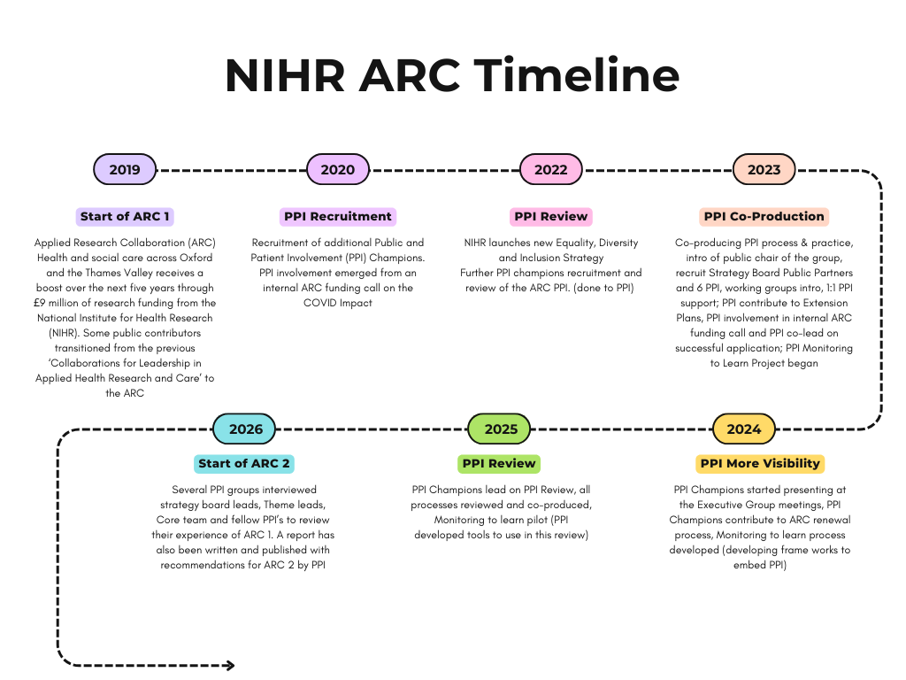
Diagram 3:

- How did we do the review?
Diagram 4: How we gathered our information

- Group discussions and interviews
This work stream aimed to capture the experience and reflections of key groups in the ARC about PPI during the ARC:
- Governance Public contributors – Strategy Board Public Partners and PPI Champions
- ARC Core Team about their experiences and reflections of PPI
- Strategy Board members
- Theme leads and deputies
The work was led by members of the PPI Champions group with support from the PPI Lead and other support staff. The whole group agreed the general approach and a framework for questions to be asked.
Each key group had an agreed team who were leading on the discussion groups and interviews for that group. Each team used the agreed framework to develop specific questions and the process for working with their group.
A mix of in person and online discussion groups and individual interviews were arranged. Where appropriate and possible discussion groups were prioritised with individual interviews used to capture the views of those unable to attend the discussion groups.
Where possible discussion groups and interviews were recorded and a transcript aided report writing. Key messages and themes were identified by one member of each team and were checked with other team members.
Each of the individual reports were then combined to create the key messages addressed in the discussions section.
- Review of ARC PPI processes and documents
This work stream aimed to review the ARC’s PPI processes and documents that had been co-created with members of the PPI Champions group. The development work had been undertaken in response to an earlier PPI review in 2022 which highlighted a greater need for understanding and clarity about the role of the PPI Champions.
We split the documents in this review into two distinct areas. Operational documents and processes and Support and learning documents and processes. This was a slightly artificial division but allowed us to split the task between two separate working groups (with some membership crossover for consistency).
The review of operational processes focused on asking the following questions:
- Are the existing documents and processes fit for purpose?
- Do the documents capture our existing practices and processes?
- What additional processes would we suggest for the future?
The review process involved a working group of PPI Champions which addressed the questions above and then presented the outputs to the whole PPI Champions group for final agreement.
The review of support and learning processes was undertaken in three phases:
- The PPI Champions working group undertook a review of existing documents. They developed new documents to capture existing practice not already recorded. They made recommendations about additional support.
- A survey of the outcomes from the initial review was undertaken with all members of the PPI Champions group. This was analysed and summarised in partnership with members of the working group.
- Using the survey data the working group revised the documents. They also produced a report of the survey findings and made some recommendations for future consideration. These final outputs were presented to the PPI Champions group for final agreement.
A more detailed report of the support and learning review process and outcomes is available.

- PPI Monitoring to Learn review and development.
The PPI Monitoring to Learn project aimed to create a resource and process that helped the ARC to better understand what PPI was happening across the ARC and how we could use it within the ARC to improve PPI quality and capacity.
As with most things there was no existing product which did exactly what we needed so we used existing resources and knowledge to inform what we did. We designed an initial set of resources that we continuously reviewed and adapted as we piloted it across the ARC Themes.
As we neared the end of the ARC we took on board all that we had learnt during the pilot and undertook a final review of the resources we had been using. We also analysed the project PPI reviews that had been undertaken. The outputs from these two processes have been used to create a detailed report.
This detailed report is available separately to this document.
- PPI activity and the impact of ARC OxTV PPI in governance.
Over the course of the ARC, we have put in place processes to record who we are involving, how we are working with our public partners and PPI Champion and Strategy Board Public Partner activity and impact. This has helped us to understand how we have developed over time, what has been done and what has been achieved.

- Findings
This section of the report details the key insights from each element of the review.
- Key insights from interviews and discussion groups in the ARC

There were remarkably similar insights across the different groups we spoke to. There were particular similarities between the thoughts of the governance public contributors, the ARC Core Team and the Strategy Board Partners. The conversations with the ARC Themes reflected many of the same thoughts but also explored PPI at a project level, thus identifying additional insights.

Commonalities across all of the groups included:
- It was acknowledged that the ARC PPI infrastructure developing and evolving PPI processes over time was important to success and effectiveness;
- Diversity is valued but needs investment to be meaningful;
- Supporting shared learning and good practice is important for PPI consistency and capacity building;
- Opportunities need to build on peoples interests and lived experience;
- It’s important to identify and reflect on challenges.
The following provides more detail about the key insights and themes identified during the group discussions and interviews with key players in the ARC. The coloured boxes identify a specific theme and each is followed by a list of insights. These are all drawn from the group summaries in appendix I.
Getting the process right is important - it can ensure a positive experience and successful involvement. It includes connecting people and building relationships across the ARC, understanding of roles and being clear about where PPI sits in the Leadership Team.
- Understanding of process, activity, roles and function are important to success and how people perceive their experience.
- The work of PPI support staff needs to be recognised and valued across the system.
- As PPI develops and grows communication is key, but it becomes more complex.
- Good chairing and support are essential to meaningful and successful involvement.
- When PPI is fully embedded it cannot be separated from other aspects of the research.
- You need the right approach in the right place.
PPI infrastructure is essential in supporting sustainability – building a robust, accessible, well-resourced and valued PPI infrastructure can help facilitate and support meaningful and sustainable PPI within the wider research environment.
- When PPI infrastructure and support is in place it becomes easier, more consistent and less burdensome for researchers.
- Individual relationships are important but robust systems help mitigate the potential fragility when those people move on.
Length of involvement can make a difference – given time and the chance to reflect the PPI system can adopt a continual improvement approach which will improve, develop and impact the wider research environment.
- Increased PPI activity overtime has led to increasing support for PPI.
- Those involved for longer have seen more growth in the PPI Champion role and appears to have led to more positive experiences.
- The response to the 2022 review has resulted in PPI improvements including increased diversity, increased PPI structure and a shift in PPI thinking – less tokenistic.
Aligning what public contributors do in PPI with their personal interests and lived experience matters – the experiences and commitment of public contributors involved in governance roles are improved when they are also provided with activities and tasks that link to their own interests and lived experiences.
- Whilst making sure that ARC PPI processes are robust is seen as valuable, the link to relatable research is also important for people and there appears to be greater satisfaction when involvement aligns with one’s own lived experience and interests.
- Personal and community links are valued and beneficial.
- There is a sense that there has been a lack of strategic ‘decision making’ and influence in terms of ARC direction with some notable exceptions: discussing issues of importance in the Thames Valley, the ‘so what’ of reporting and the ARC extension
Sharing what we learn about PPI is important for capacity building – these learnings can support knowledge and confidence building for researchers and public contributors if we can find innovative ways to capture and share them across the ARC.
- Understanding that involvement can support personal growth for public contributors is important and should be valued.
- We need to be better at sharing good practice in order to support capacity building.
Diversity is valued - efforts to focus on and invest in inclusion and diversity are essential but we should also assess and reflect on the success and challenges of these activities.
- Increased diversity is valued but questions are raised about the value versus the increased cost of wide geographic involvement.
- Reaching out to and involving seldom heard voices takes time, trust building and creativity.
Challenges and missed opportunities – there will inevitably be missed opportunities but the reflective process allows us to identify and learn from them. Creating safe and non-judgemental spaces will encourage reflective PPI practice and learnings about missed opportunities.
- PPI is often present at the beginning and end of projects but opportunities can be missed to involve people early in research prioritisation and during the middle stages of projects.
- Balancing different perspectives can mean lived experience gets lost.
- Researchers struggle to know how to involve members of the public in more complex or academic projects.
- Lack of time in the ‘system’ is the problem not a lack of belief in the value of PPI.
- Funding expectations can push towards compliance and the risk of PPI becoming ‘a tick box exercise’.
- Governance public contributors want opportunities to engage their lived experiences and interests.
- There needs to be a greater focus on knowledge mobilisation, implementation and building capacity.
- Think more about how to maintain and stimulate involvement in wider ARC activity and planning.

- Key insights from the review of ARC PPI documents and processes
The PPI Champions co-created processes and documents to record how we work. This has provided a much clearer picture of the role of public contributors in the governance of the ARC.
Ours ways of working together have also modelled good practice in terms of co-producing with public contributors. We did this by creating the essential components for successful co-production: a warm welcome, space to talk, inclusivity, ongoing individual support for public contributors and most important of all genuine sharing of power.
As a result of the review:
We updated existing processes to better reflect what we were actually doing. In the main the changes made were minor changes or additions to wording to add clarity and/or current practice that was not reflected in older documents.
One of the most significant changes was to finalise and record the information about and process surrounding the groups chair role plus the formal addition of a co-chair role and a small planning group to support the work of the chair.
Another outcome of the review was to record the processes that were already in place but were not already documented or formally agreed. In most cases these had been informally agreed so we took this opportunity to formally record and agree them or they were co-produced and agreed with the PPI Champions group.
Some processes addressed issues that had arisen over time (either within the ARC or more broadly in the PPI networks we connect with) such as role boundaries and dealing with difficult issues. Others were created to record our existing practice (e.g. records, individual support and team building etc).
We also agreed to create separate documents for some issues that were embedded in other processes but we felt should also have a standalone document for clarity (e.g. confidentiality and conflicts of interest).
In addition, for our support and learning activities we compiled a report of all the survey responses. It contains the feedback provided with a summary of what action was taken or recommended for the future. A further document was created that highlights all the suggestions we could not include in the ARCs final processes but that are recommended for consideration in the future, please see appendix III for further details.
Finally, we identified recommendations for the future:
- The main recommendation is to make use of the documents and processes we have co-created, adapting them to individual context as needed.
- We also recommend creating a frequently asked questions document (and/or space on the PPI webpages) which provides a questions based route to searching for information about processes.

- PPI Monitoring to Learn Development Project and Pilot
The PPI Monitoring to Learn project set out to develop a resource that could be used to plan, monitor, and evaluate PPI in ARC projects in a consistent and robust way. We also aimed to establish how we could use the data collected to improve quality and build capacity for PPI across the ARC. We are therefore reporting on two separate but connected activities: the development process and the results from the pilot. Both were overseen and co-designed with the ARC’s governance public contributors, known as PPI Champions.
Developing and reviewing the PPI Monitoring to Learn Process
The co-design group took an iterative development approach. They continually reviewed and adapted the resources as they were piloted. As the ARC drew to a close, they undertook a final review and created a combined planning and monitoring form. They also developed PPI impact and evaluation guidance.
What we learnt about PPI in ARC OxTV from the Monitoring to Learn Pilot
The oversight group collated and analysed the information gathered about PPI in the ARC through the PPI Monitoring to Learn process. The key learnings were:
The Monitoring to Learn Process supported knowledge building and relationship development between public contributors and researchers. This in turn led to the creation of ‘safe and non-judgemental spaces’ to discuss concerns about enablers of and barriers to PPI.
The monitoring forms identified multiple cases where PPI changed the way a study was conducted and/or impacted the outputs of the study. They also showed that over the course of the ARC that a consistent and supportive PPI infrastructure can help maximise the impact of PPI.
Researchers acknowledged that PPI could be broad, deep, and impactful. It could also keep them grounded, provide a sounding board and provide context. On reflection they also understood the importance of the PPI approach being appropriate for the community you want to involve and that the process you plan needs to be flexible, so you can adapt to individual need.
ARC projects reflected all six of the UK Standards for Public Involvement and supported the implementation of all 5 NIHR PPI Strategic Commitments.
Recommendations for the future:
- Embed in ARC Practice. ARC Thames Valley should embed the PPI Monitoring to Learn process in their work. There should be a requirement for all Applied Research Collaboration Thames Valley (ARC TV) research projects to develop a PPI plan and to monitor it. They should monitor and adapt the resource as needed.
- PPI Knowledge Mobilisation. Use the outputs from the PPI Monitoring to Learn process to identify opportunities to share good practice and build knowledge. This applies to both public contributors and academics. They can also be used to identify where central support could further enhance PPI capacity building (for example where central infrastructure could support PPI activity more effectively and where central learning opportunities can support capacity building).
- National PPI Agenda. Explore how to better embed the UK Standards for Public Involvement and the NIHR PPI Strategic Commitments into the process.

- PPI to Activity and impact of ARC OxTV PPI in governance.
The tables in appendix II identify and summarise some of the important information about PPI governance in ARC activity over time. It is important to note the impact of the 2022 PPI review in the increase in activity in this area. For reference Diagram 3: Visual Timeline on page 6 (also in appendix V) explores some of the key milestones of the ARC.
The first table provides details about the 11 working groups established to support the work of the PPI Champions and development of the ARCs PPI systems. The working groups weren’t just a construct but each group had a meaningful purpose and objectives. They were held to account through the full meetings of the PPI Champions group and the wider ARC governance system. Each working group produced valuable outputs that are identified in the table.
The second table provides information about activity levels. We can see a clear change of pace in activity after the 2022 PPI review. The numbers of PPI Champions doubled in the year following the review. The number of active working groups increased from zero to seven in this period and the number of meetings increased alongside the increase in groups. We also saw a rise in regular personal support and other activities.
The third table is a summary of the PPI impact log for the ARC. It identifies some of the key impact highlights from 2023 when the log began. This sample of impacts reflects the breadth and depth of the PPI Champions on PPI development and activity in the ARC. It covers:
- strategic influence
- data collection
- operational guidance
- PPI monitoring
- funding decisions
- feedback process development
- engagement with the wider governance structure in the ARC
- support for researchers undertaking PPI
- evaluation of ARC PPI
The fourth table is a summary of the key findings from the ARC’s inclusion monitoring in 2025. Whilst we can’t share our PPI Champion specific data we can confirm that the group data indicated a diverse group. The group members learnt about PPI from a variety of places. Their length of involvement ranged from newly involved to more than 10 years of experience. They had considerable lived experience between them and they came from diverse communities.
The Public Contributor stakeholder map in Appendix VI helps explain the depth and breadth of lived experience, knowledge and interests that our PPI governance public contributors brought to the ARC. This information is drawn from multiple sources including our skills audit (instigated and facilitated by our PPI Champions), building broad and meaningful relationships with individuals and our inclusion monitoring. It has helped us see each other as individuals and more than the ‘role’ we fulfil. It has enabled us to value all experience and knowledge and to offer opportunities that allow people to excel, develop and add meaning.
Recommendations for the future:
- Embed ongoing review and reflection to ensure continual improvement.
- Devolve decision making and meaningful activity to public contributors to widen the skills pool and to make best use of available resources.
- Take a more pro-active approach to engaging and integrating the PPI governance team with the core ARC team, the wider ARC community and PPI networks.
- Strive to value equally and understand the different lived experiences, knowledge and expertise that individuals bring to the process, regardless of the role they fill.
Diagram 5: Summary of review findings
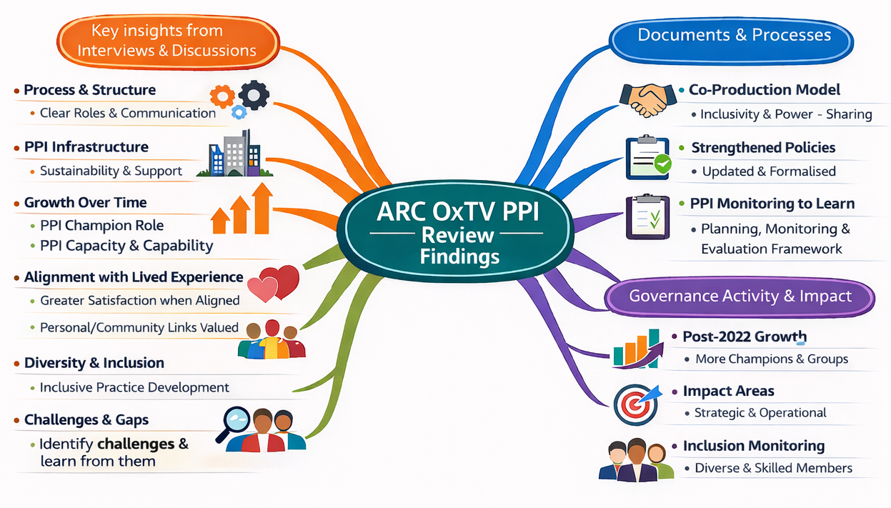

Conclusions
The following is a summary of the key findings that have come out of all elements of this PPI review: the group discussions and interviews; the review of PPI documents and processes; the PPI Monitoring to Learn project and the PPI activity and the impact of ARC OxTV PPI in governance. Many of the messages were consistent, albeit expressed differently, across the four key components of the review.
Partnership working is key. The cornerstones of co-production and co-creation are invaluable: a warm welcome, space to talk, inclusive practice, ongoing individual support for public contributors and most important of all genuine sharing of power.
Power sharing is vital and can only be done meaningfully if you genuinely value all knowledge and lived experience equally and devolve power to your public partners.
Safe spaces are essential to be able to both surface and explore challenges and barriers to PPI. Those spaces need to be safe for both public partners and academics and need to apply non-judgemental approaches to achieve this. A key part of this process is to build in space to talk and enable relationship building opportunities.
PPI approaches and activities need to be fit for purpose. They need to meet the needs of the community to be involved so their contribution can be as meaningful as possible. We can look at what others did before but we always need to think about and adapt to the current context.
Reward and recognition payments for time are important but so are personal interests, lived experience, personal development and respect. PPI opportunities need to be valued financially but also offer opportunities for personal growth.
(Local) PPI Infrastructure supports PPI consistency and continuous improvement as it allows processes to be developed and maintained over time. It offers support to the wider research system ensuring that academics have local access to guidance and up to date information and resources. This in turn supports PPI success and effectiveness. There was a clear message that PPI is valued but there is often a lack of time/resource to do it well. Good local PPI infrastructure was seen as a way to help with this as it can build:
- PPI processes that are clear, understood and consistently implemented. People need to be confident about what they are doing and who to ask if they are in doubt.
- PPI sustainability in the longer term. PPI infrastructure can think about how to maintain relationships, how to plan for when people ‘move on’, how to ensure consistent and up to date PPI processes.
- Diversity, which is widely valued and seen as important, through collective investment that can be used to build and improve meaningful engagement and involvement with diverse communities.
- Opportunities to share learning and good practice to facilitate PPI capacity building.
Diagram 6: PPI Infrastructure can offer

Leading to:
Capacity to support individual research projects and teams
PPI capability and capacity building
Confidence to do PPI

Summary of Recommendations
The following summarises all of our learning and recommendations that have come out of this review of Patient and Public Involvement (PPI) in the Applied Research Collaboration Oxford and Thames Valley (ARC OxTV) 2019 -2026. This is not a substitute for the detail in the report and appendices but does attempt to summarise and capture the ethos and direction of our recommendations.
Continue doing what has worked well:
- Make use of the documents, processes and resources we have co-created.
- However, everything is a work in progress so pilot and adapt them to individual contexts as needed.
- Use the resources we have created to identify opportunities to share PPI good practice and build knowledge, capability and capacity across the whole PPI community.
- Continue to devolve decision making and meaningful activity to public contributors.
- Strive to equally value and understand the different lived experiences, knowledge and expertise that individuals bring to the process regardless of the role they fill.
Do more of what we already know works:
- Make a habit of providing information (or ways to access information) in different formats such as documents, aural/video outputs, visuals, animations, tips, FAQs.
- Take a more pro-active approach to engage and integrate the PPI governance team with wider ARC planning, activities, processes and support functions through robust relationships with the core ARC team, the wider ARC community and PPI networks.
- Think carefully about where PPI sits within the leadership team.
- Build on what we have learnt and explore our detailed recommendations.
- Extend the good PPI practice we have into more areas such knowledge mobilisation and implementation, building capacity, research prioritisation and designing from the very beginning and throughout the whole research cycle for every project.
Embed quality:
- The UK Standards for Public Involvement and the NIHR PPI Strategic Commitments into our processes and practice.
- Build capability, capacity and confidence across the system for public partners, PPI leads and researchers.
- Recording impact and activity.
- Ongoing review and reflection to ensure continual improvement.
To be successful requires a partnership approach with commitment from across the ARC – board members, senior staff, academics and governance public contributors. Each has their role to play in embedding and learning form PPI throughout the ARC.

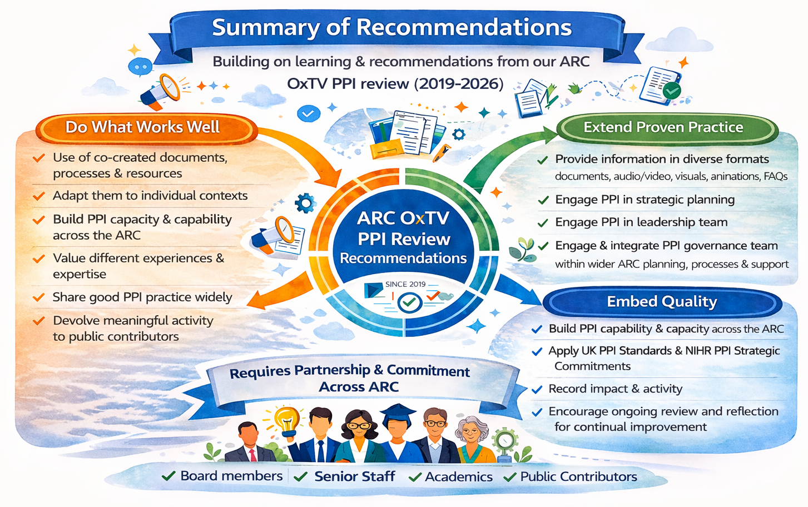
Diagram 7: Summary of review recommendations

