Immigration, Health and Wellbeing - IV Edition
Department of Economics, Posvar Hall, University of Pittsburgh
May 5th and 6th 2019
May 5
Registration and Coffee 1:30am-2:00pm
2:00am-2:15am– Welcome by Osea Giuntella (Pittsburgh)
Session 1 : Migration and Health
Chair: Osea Giuntella (Pittsburgh)
2:15pm-2:45pm – Immigration and the Health of Older Natives in Western Europe (Escarce and Rocco) – presented by Lorenzo Rocco (University of Padua)

2.45 pm Discussant: Carlos Vargas-Silva (University of Oxford)
3:00pm-3:30pm –Health, Immigration, and Health Care Expansion (VuXuan) – presented by Vu-Xuan (University of Kansas)
330pm: Discussant: Ning Zhang (University of Pittsburgh)
3:45.pm-4:15 Birth in Hard Times: When Your Ethnic Network Can Keep You Up or Drag You Down (Bertoli, Grembi, Nguyen)-presented by Paola Bertoli, University of Prague

4.15pm: Discussant: Tianyi Wang (University of Pittsburgh)
4:30pm-4:45pm Coffee Break
4:45pm-5:45pm Keynote 1: Professor Hillel Rapoport (Paris School of Economics)

6:30pm-7:30pm Dinner
May 6
Coffee: 8.30am
Session 2 : Modelling Migration, Human Capital, and Neighborhood Choices.
Chair: Brian Kovak (Carnegie Mellon University)
9:00am-9:30am The Dynamics of Return Migration, Human Capital Accumulation, and Wage Assimilation (Adda, Dustman, Gorlach)- presented by Joseph-Simon Gorlach (Bocconi University)

9.30am Discussant: Rania Gihleb (University of Pittsburgh)
9:45am-10:15am An Estimable General-Equilibrium Structural Model of Immigrants’ Neighborhood Sorting and Social Integration (Hwang)- presented by Yujung Hwang (Yale University)

10.15am Discussant: Rebecca Lessem (Carnegie Mellon University)
10:30:00pm- 11:00pm: Refugees’ Self-selection into Europe: Who Migrates Where? (Aksoy and Pootvaara)-presented by Cevat Giray Aksoy (European Bank for Resconstruction and Development)

11am: Discussant: Daniel Cohen Pirani (University of Pittsburgh)
11:15-11:30 coffee break
Session 3: Refugees, forced migration
Chair: Catia Nicodemo (University of Oxford)

11:30-11:45: Consequences of Immigrating During a Recession: Evidence from the US Refugee Resettlement Program (Joshua Mask)-presented by Joshua Mask (University of Illinois-Chicago)
Discussant: David Slusky (University of Kansas)

12.00-1.00pm Keynote 2:– Jennifer Hunt (Rutgers Univesity)

1.00pm-2:15pm Lunch break and Poster Session
Session 4: Migration Networks
Chair: Daniel Cohen-Pirani (University of Pittsburgh)

2:15m-2:45pm The International Transmission of Local Economic Shocks Through Migrant Networks ( Caballero, Carnegie Mellon University) presented by Maria Caballero (Carnegie Mellon University)
Discussant: Catia Nicodemo (University of Oxford)
3:00pm -3:30pm Italian Migration to the United States:The Role of Pioneers' Locations (Brum)-presented by Mathias Brum (Instituto de Economia, FCEA-UdelaR ,Montevideo)
Discussant: Allison Shertzer (University of Pittsburgh)
3:45-4:00 coffee break
Session 5: Immigration, Children, and Crime

Chair: Carlos Vargas-Silva
4:00pm-4:30pm : China’s Left-Behind Children: A New Look at the Impact of Intergenerational Care on Cognitive and Non-Cognitive Performance (Xu, Liu, and Zhao) presented by Huanan Xu (Indiana University)
Discussant: Osea Giuntella (University of Pittbsurgh)
4:45pm-5:15pm: The Skill Development of Children of Immigrants (Hull and Norris) presented by Marie Hull, (UNC Greensboro)
Discussant: Brian Kovak (Carnegie Mellon University)
5.30 pm-6pm: Followed by Violence: Forced Immigration and Homicides (Chauvin and Santos)-presented by Raphael Santos (Universidad de Los Andes and CEDE)
Discussant: Jakub Lonsky (University of Pittsburgh)

6.30: Drinks

List of the participants
Acuña Julio , Ph.D. Universidad San Francisco de Quito
Asiedu Edward, University of Ghana Business School
Cevat Giray Aksoy, European Bank for Reconstruction and Development
Bertoli, Paola, University of Economics, Prague
Brum, Mathias, Instituto de Economia, FCEA-UdelaR, Montevideo
Caballero, Maria, Carnegie Mellon University
Cardozo Adriana, University of Goettingen
Cohen-Pirani, Daniele, University of Pittsburgh
Cuadros-Menaca Andres, Universidad Icesi, Cali-Colombia
Di Iasio Valentina, University of Insubria, Varese
Gihleb, Rania, University of Pittsburgh
Giuntella, Osea, University of Pittsburgh
Gorlach, Simon-Joseph. Bocconi University
Hull,Marie UNC Greensboro
Hwang, Yujung, Yale University
Kanatip, Winichakul, University of Pittsburgh
Kovak, Brian, Carnegie Mellon University
Lessem, Rebecca, Carnegie Mellon University
Lonsky, Jakub, University of Pittsburgh
Mask, Joshua, University of Illinois-Chicago
Nicodemo, Catia , University of Oxford
Rocco, Lorenzo, University of Padua
Santos, Raphael, Universidad de Los Andes and CEDE
Shertzer, Allison, University of Pittsburgh
Slusky, David, University of Kansas
Vargas-Silva, Carlos, University of Oxford
Winichakul, Kanatip (Pun), University of Pittsburgh
VuXuan, Hoa, University of Kansas
Xu, Huanan, Indiana University
Zhang, Ning, University of Pittsburgh
Wang, Tianyi, University of Pittsburgh

Location:
Campus Map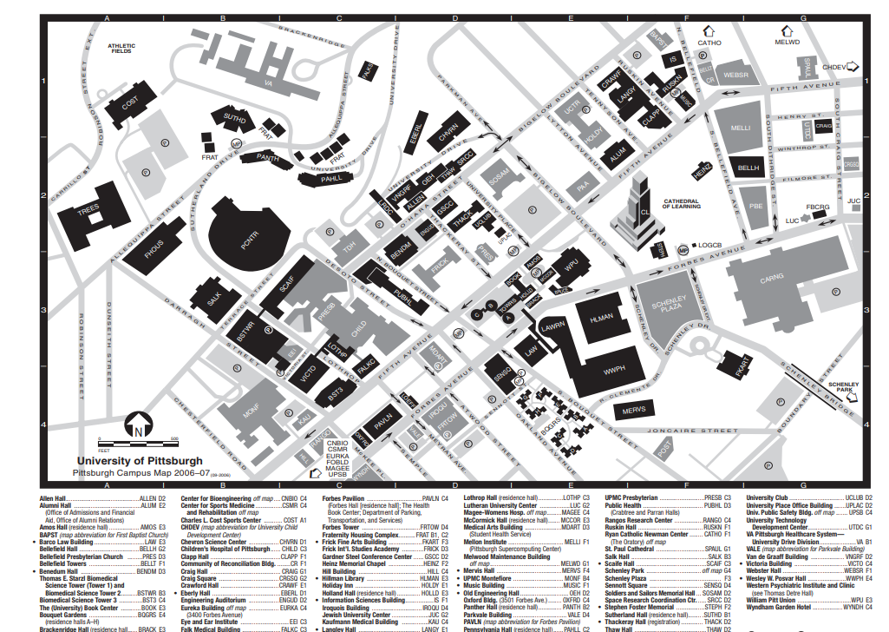
Possible Accomodations:
Ace Hotel : https://www.acehotel.com/pittsburgh/?gclid=Cj0KCQiAtP_iBRDGARIsAEWJA8jHzqQ_wUDTBKoI-RI_xuedJHCRBzElYnaJCxJ4cFl9CC3yBLizUcQaAthREALw_wcB&gclsrc=aw.ds
Wyndham Pittsburgh Hotel: https://www.guestreservations.com/wyndham-pittsburgh-university-center/booking?gclid=Cj0KCQiAtP_iBRDGARIsAEWJA8jXkgdYe86lQz2vflTrt08clDOwO0pRL2Po7OGQ1FoZWjmK0Ai6BTsaAjzYEALw_wcB
Hotel Indigo: https://www.ihg.com/hotelindigo/hotels/us/en/pittsburgh/pithb/hoteldetail?qDest=Pittsburgh,%20PA,%20United%20States&qCiD=10&qCoD=11&qCiMy=12019&qCoMy=12019&qAdlt=1&qChld=0&qRms=1&qWch=0&qSmP=1&qIta=99504425&glat=SEAR&setPMCookies=true&qRtP=6CBARC&qAkamaiCC=US&srb_u=1&qRad=30&qRdU=mi&presentationViewType=null&qBrs=re.ic.in.vn.cp.vx.hi.ex.rs.cv.sb.cw.ma.ul.ki.va
Marriot: https://www.marriott.com/hotels/travel/pitel-springhill-suites-pittsburgh-bakery-square/?scid=bb1a189a-fec3-4d19-a255-54ba596febe2

There are many Airbnb options close to campus.

