**Desk booking trial app**

The Medical Statistics, Health Economics and CEBM groups recently completed a desk sharing trial aided by the use of a desk booking app to help manage the departmental space limitations as the department continues to grow.

**Challenges**

* Limited space to allocate additional desks to growing teams
* Delays to new building development plans
* Hybrid working adding complexity to fair desk allocation
* Need to retain flexibility for changes to on-site working days
* Equity between the different groups within the department

**Actions**

Several different desk/space management methods were reviewed taking into account accessibility, app availability, ease of use, ease of admin set-up/management, policy conformity and cost. This included other systems created in-house in the university. It should be noted that this excludes products that integrate with Teams owing to the universities IT security protocols.

The three groups trialled desk sharing supported by the desk booking app ‘Clearooms’ to allow for flexibility for how desks are used to address these challenges and also available to use via computer or phone app.

**Trial set up**

* Group coordinators collated desk use across their groups for days of the week team members are generally working onsite.
* Group coordinators identified desks unsuitable for desk sharing, such as where staff worked onsite full time or had specialist equipment setup for their work or disability requirements, and provided this data to the trial organiser.
* The trial organiser setup the desk booking app and created a floor plan giving desk availability as provided by group coordinators.
* All trial participants were added as app users and sent an invite email and instructional video on how to use the app.
* Trial participants were then enabled to search, book and cancel desks within the app for the days they intended to be in the office.
* Amendments were made to desk availability during the trial as staff and desk usage changed.
* Trial participants were invited to share their feedback on the trial.

**Results**

Of the trial participants 17% completed the feedback survey of their experience to the following questions.

**How often have you needed/do you need to book a desk?**

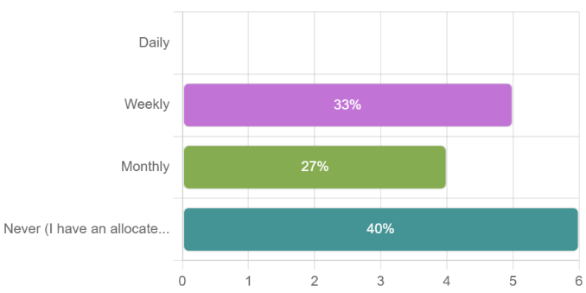

**How have you found Clearooms to manage your desk bookings?**

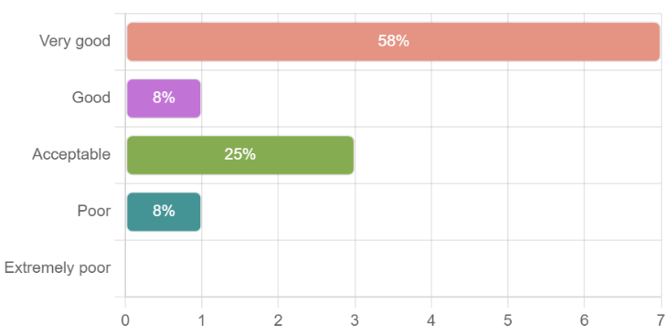

**Would you recommend Clearooms be used throughout the department for desk, meeting room and POD room bookings?**

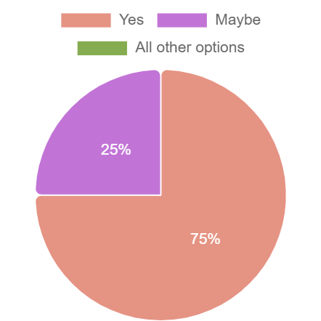

**How would you feel about moving away from allocated desks to desk booking across the department?**

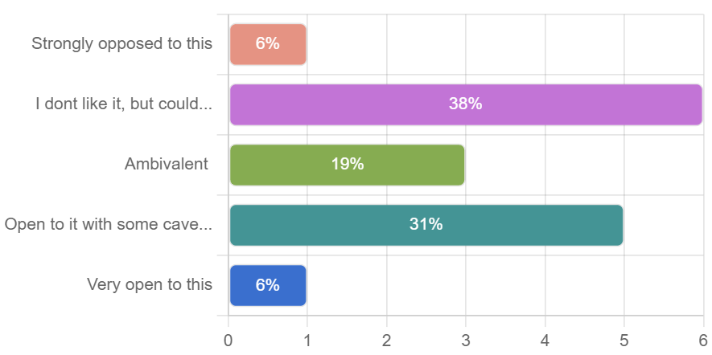

**Other comments and suggestions:**

“*The underpinning data is over 6 months out of date, meaning that desks are incorrectly classified. The department turnover of staff is relatively high, and there needs to be a robust process to ensure that data on desk availability is correct and up to date.”*

*“Need Accurate data on desk allocations.”*

*“The coordination of reserved desks for specific days did not always work. Communication needs to be improved.”*

*“Clear expectations and ways it works might be helpful.”*

*“The website feels a bit 1990's. I'd much prefer an app on the phone that I could use. Or maybe to reduce our technical debt, using an existing option within Microsoft Teams which we all have access to.”*

*“I think some 'rule of thumb' for 'equity of desk use' is important. I am in the office for a minimum of 3 days a week and I have a desk allocated to me which I consider to be fair. For staff not wishing to be in the office as often, then it seems sensible that desk space is shared in a method similar to empty office space which supports the notion that the desk/office space is available for the people who wish and need to use it. I do think the departments' occupancy rate is too low for space not to be shared between colleagues.”*

**Conclusion**

Actions taken in response to the feedback received.

**Incorrect Data:** Any desk booking app will only be as accurate as the data available on that date. This has been rectified by creating more system admin roles to allow Group Coordinators to update desk usage changes and all staff requested to update Coordinators with any changes.

**Product review:** A variety of different desk/space management methods were reviewed including apps already being used in the university, in-house booking systems created in other departments using Excel and SharePoint and new apps not currently in-use. These were judged on the basis of accessibility, phone/app availability, ease of use, ease of admin set-up/management, policy conformity and cost. This excluded products that integrate with Teams owing to the universities IT security protocols, which was explored with central IT.

It should be noted that the universities Digital Transformation Project are also currently investigating desk booking to roll out more widely across the university.

Several departments around the University are successfully using an app called [Eden](https://www.edenworkplace.com/video/desk-booking), which the Department will use pending a university-wide product is established.

*“The app is very clear and easy to use. Some of our members of staff were very reluctant in wanting to share desks/hot desk as they felt it would be too much hassle. After seeing how easy the app was they are more willing to share their desk/hot desk.*

*In the start, there were a few glitches regarding what desk should have been an available desk but this was easily resolved.”*

Nicola Pidduck, Personal Assistant to Professor Rafael Perera and Programme Manager

