Line Manager new starter guidance
- New starter process
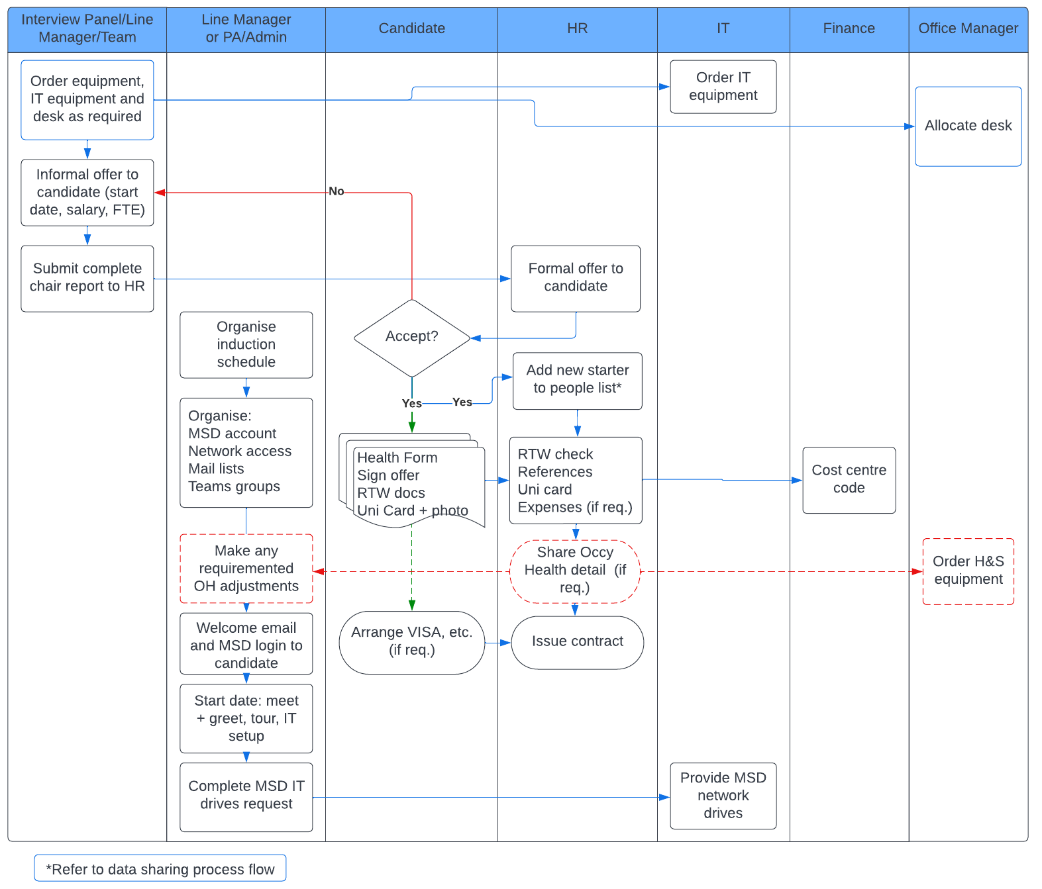
- Line Manager and Core Admin responsibilities
Who | Action
Line Manager | Refer to Line Manager checklist in Step 3
Communications | Add to staff intranet page
 | Sent welcome to Dept email / link to Dept Induction course
 | Add to internal mailing lists
HR | Add to Teamseer
 | Add to Simitive
 | Follow up with Occupational Health for any access or equipment requirements
 | Create PeopleXD and payroll record
IT/IG | Create IG/PRISM account
 | Prepare laptop/desktop
 | Action network drive request
Office Manager | Set up phone
Finance | Add to salary splits doc for salary coding

- Line Manager checklist
When | Action | Who | Complete
Appointment request | Arrange working space for recruit | Line Manager/PA
Appointment request | Request equipment (laptop, etc) from IT | Line Manager/PA
Before start date 3 | Apply for MSD IT Account and network access (once SSO, email and card number received from HR) | Line Manager
Before start date 4 | Email new starter first day instructions, MSD IT login instructions, start time, location (TEMPLATE New Starter Email) | Line Manager
Before start date 2 | Set induction programme to include key information, meeting dates, training dates (TEMPLATE Induction Schedule) | Line Manager
Before start date 1 | Identify team member to act as induction buddy and if helpful arrange a pre-start meeting/call | Line Manager
First day | Check University card and login details given to new starter and that they have registered for network login | Line Manager
First day | Conduct a building tour | Line Manager, PA or Buddy
First day | Basic Health and Safety induction: evacuation process, fire assembly point, first aid facilities and DSE self assessment via your SSO login | Line Manager
First day | Introduce starter to work colleagues and buddy/PA | Line Manager, PA or Buddy
First day | Add starter to Teams and meeting groups | Line Manager or PA
First day | Discuss working hours, dress code, team communication groups, social activities, etc. | Line Manager
First day | Show starter IT facilities such as printer, scanner etc; kitchen and coffee facilities etc. | Line Manager or buddy
First day | Discuss job description – clarification of role and expectations, identification of development needs | Line Manager
Week 1 | Set objectives/goals for the first few months (see Probation Guidance) | Line Manager
Week 1 | Ensure individual completes mandatory training on IG policies and SOPs and takes the Quiz, information security and data privacy awareness course, research governance and those relevant to role | Line Manager
Week 1 | Accompany starter to coffee morning | Line Manager or buddy
Week 1 | Introduce starter to library if relevant | Line Manager or buddy
Week 1 | Refer to additional training, including courses relevant to line managers, supervisors and those who will participate in recruitment panels | Line Manager
End of Week 2 | Check that departmental induction has been completed | Line manager
End of Week 2 | Check that points on this list have been addressed | Line Manager

Mandatory Training
All members of the department must undertake the following training:

Training | Frequency | Reason
Information Security and Data Privacy Awareness course (available on the Cosy application) | Annual | To protect the data assets of the department, enable public confidence in our research and to meet the standards of the NHS Data Security and Protection Toolkit (which enables us to access patient  data)
Quiz on IG policies and SOPs | Annual | To promote understanding of key data security and privacy controls as set out in the Departmental IG policies and SOPs
Equality and Diversity Briefing | Triennial | To ensure that the Department is not held back by explicit or unconscious biases and  that everyone benefits from an inclusive environment

Chairs of recruitment panels must and other members of recruitment panels should undertake the following training:
Training | Frequency | Reason
Recruitment and Selection course | Triennial | To ensure that candidates are recruited fairly on the basis of skills and suitability, and to promote diversity

Managers and supervisors must undertake the following training:
Training | Frequency | Reason
Managing people: key processes (E-learning course) (ox.ac.uk) | Once | To ensure that managers are familiar with basic procedures
Supervisors responsibilities | Once | To ensure managers and supervisors understand their safety responsibilities

