We are seeking case studies of good practice in PPI to showcase.
If you have been involved in a successful PPI initiative that you would like to share with us, please complete the template form attached and send it to Lynne Maddocks
We are seeking examples from any aspect of the research cycle:
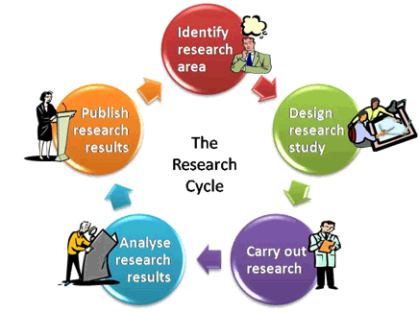
Chocolate reindeers available for all submissions!

Send to lynne.maddocks@phc.ox.ac.uk or phone to discuss on 17198, by 6th January.
P.T.O for template case study

Showcase your PPI
Summary
Concisely explain the research project, who was involved and who benefited (in a nutshell). It’s often easier to write this once you’ve completed your first draft.

The purpose
Describe the original aims or objectives of your project. What was the problem, challenge or opportunity that got you started?

What was the PPI?
Describe what PPI you planned and why. What did you want the public perspective to achieve on your project? How did you decide what sort of PPI Contributors you wanted (patients, public carers etc.) Say how you recruited your PPI Contributors. Give details of how many PPI Contributors you had and how you worked with them? How many meetings did you have?

Breadth
Explain if you had PPI before funding? State if your PPI Contributors were recruited to other work in your department when they finished with your project.

What you did (and what worked!)
Mention what elements stood out as key to your PPI’s success. You might have rejected some methods, or tried things and changed your mind. Just tell the story as it was. Remember to cover the whole research cycle through to providing feedback to your PPI Contributors.

Timescales
Did you have the same PPI Contributors throughout the whole project? Explain any changes to personnel in PPI and how relationships developed.

The difference PPI made in your project
Explain how you recorded the PPI input and how it impacted on what you did. Describe the outcomes and benefits of having PPI in your project (Imagine a tax payer reading this and wondering what the time and effort was for). Examples could include helping you to get funded or approved by ethics, improving your capacity to recruit & retain participants, making the research topic more focused on patient benefit, enabling the research to be run more cost effectively or faster, improved partnerships and cultural change. You can include examples of differences for individual researchers or PPI Contributors.

What you learnt
Reflect on the learning for the people, and the organisation (be honest about what went wrong and why)

What people said
Quotes from colleagues or PPI Contributors will bring your case study to life.

With hindsight…
Say what you would do differently if you were to do it again

Conclusions and what next?
Where have you got to at this stage? Looking forward, are there future plans or spin-offs?

Contact details
Give your preferred contact details.

