Important information regarding the booking process at
St Luke’s Chapel

The Chapel is managed by the Estates Services Facilities Management team and is available to book from the 18 January 2016. It can be used for teaching, research and activities related to Oxford University. If you have any questions regarding bookings please do contact us on:
Contact us
Lecture and meeting room bookings | Facilities Helpdesk.  T: 01865 (2) 70087  E: facilities@admin.ox.ac.uk
University event bookings | T:01865 (2) 78787  E: enquiriesstlukes@admin.ox.ac.uk

Term time bookings (Monday – Friday 08.30 – 5.00pm)
Priority for St Luke’s Chapel space is given to University lectures. If you would like to book a lecture please contact the Facilities Helpdesk who will issue you with a log-in for lecture bookings T: 01865 270087 E: facilities@admin.ox.ac.uk. There are no restrictions on how far in advance you can book lectures. Lectures are booked on a first come first served basis. Lectures can be booked from Monday – Friday 08.30 – 5.00pm.
Once all lecture bookings have been made, any excess space in the Chapel can be booked for meetings. The space will be opened up for meeting room bookings on the Friday before term starts. This can be accessed via FM online here.
Internal pricing rates
To cover operating costs, the Chapel charges a small fee of £45 per hour for all lecture and meeting room bookings. A lecture or meeting room booking cannot be made via FM online without a department cost code. At the end of every month this cost will be journaled back to your department.
Available room formats
The Chapel offers three different formats:
Format | Capacity
Lecture/theatre style | 90 seated (chairs – no tables)
Boardroom style | 24 seated – chairs with a u-shaped table
Classroom style | 30 seated chairs and tables

Catering can be ordered for meetings (not lectures) when you make a booking via FM online. Please see our floorplans at the bottom of this document for more information.
Equipment
AV: The Chapel comes with basic AV equipment – laptop and projector. The white wall is used as a screen. Laptops can be brought and plugged into the system. While we do have a number of connection leads, we strongly advise you to supply your own. The chapel also comes with a flipchart, pad and pens.
PA: The Chapel has a Bose PA system which has:
- 1 x lectern/swan neck with mic

- 1 x roving/handheld mic
- 1 x lapel mic

Internal University events – term time and out of term (Monday – Friday 5.30 – 11.00pm)
The Chapel provides an attractive setting for events with beautiful original stained glass windows. On weekday evenings (5.30 – 11.00pm), weekends (9.00am – 11.00pm) and out of term, the Chapel is available to hire for internal University events. Bookings can be made by contacting enquiriesstlukes@admin.ox.ac.uk. Further information about using the Chapel for events can be found on our webpages here.
The Chapel is suitable for a range of events including:
- Drinks receptions for up to 90 people
- Talks and lectures theatre style for up to 90 people
- Small meetings and talks for up to 30 people in a classroom format
- Small meetings boardroom style for up to 24 people
Other formats can be offered, eg exhibition space. Currently we do not offer dinners but it is something we hope to offer summer 2016 onwards.
Internal pricing rates
To cover operating costs the Chapel charges £150 per hour for internal events.
Floorplans - Theatre style – 90 people
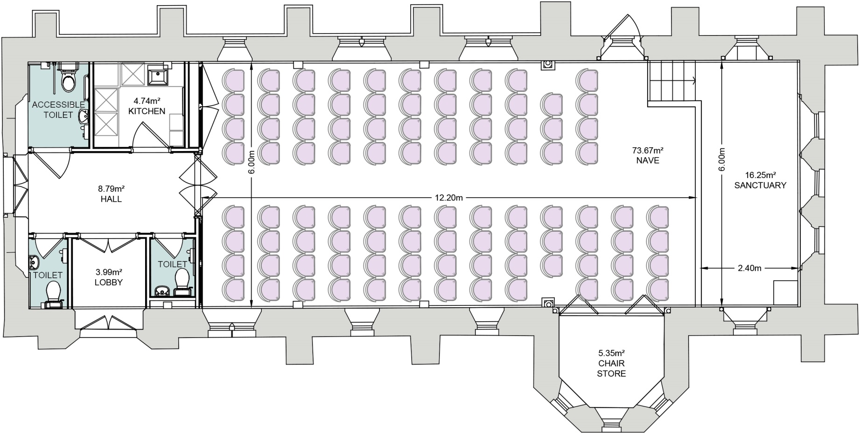

Entrance to Chapel

Floorplans - Boardroom – 24 people
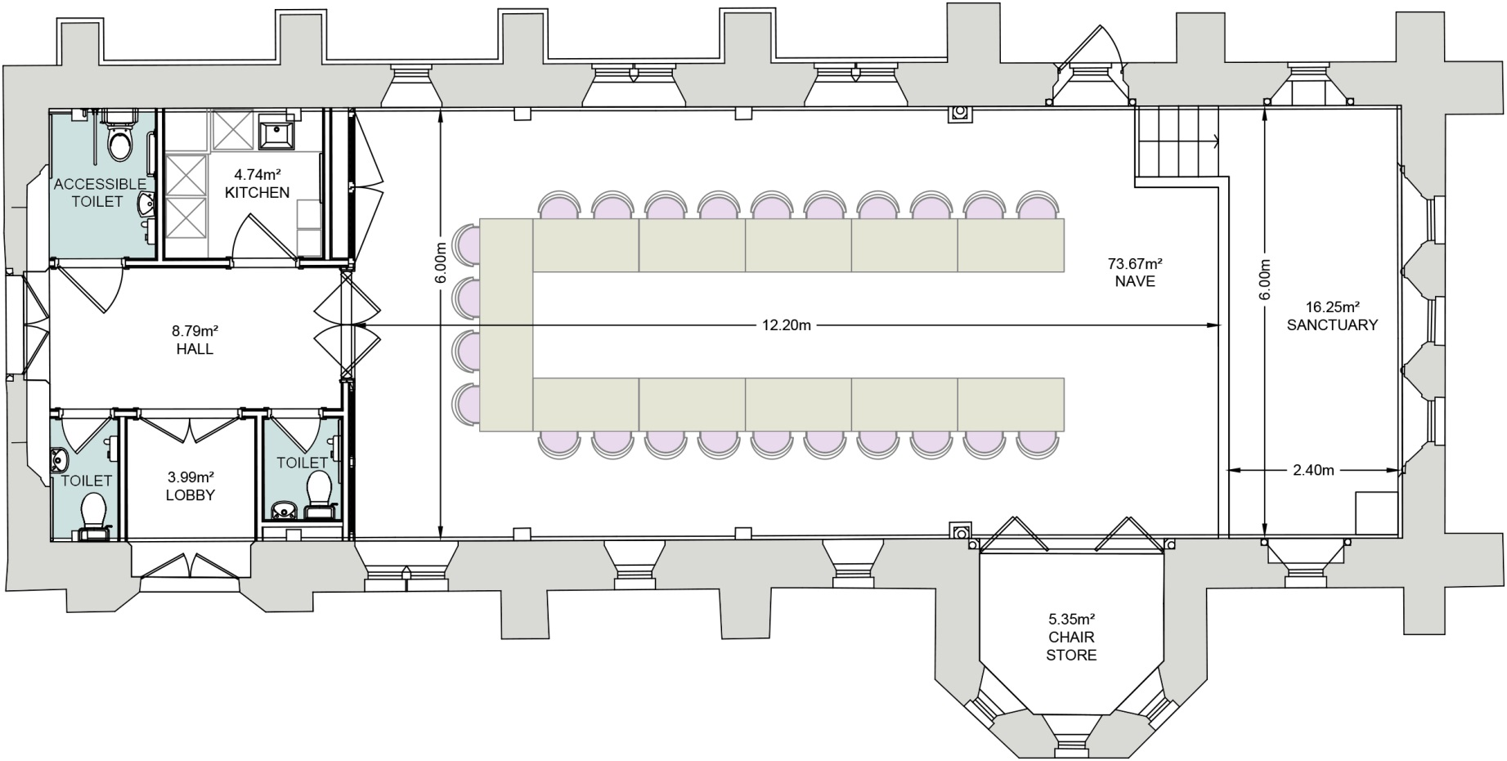

Entrance to Chapel
Floorplans - Classroom – 30 people
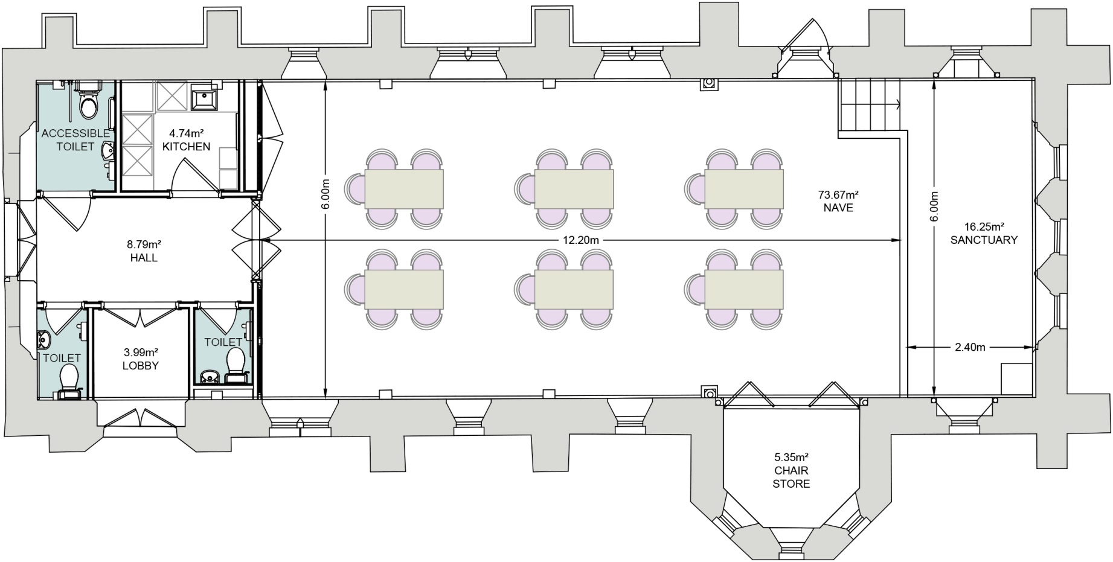

Entrance to Chapel

