Introduction to Patient and Public Involvement in Research (PPI)

Public and public involvement (PPI) in health and social care research is defined by the Health Research Authority¹ as being “done ‘with’ or ‘by’ the public, not ‘to’, ‘about’ or ‘for’ them.”

This includes, for example, working with research funders to prioritise research, offering advice or expertise as members of a project steering group, commenting on and developing research materials, undertaking interviews with research participants.

There is increasing evidence that health research conducted with meaningful PPI improves research and achieves better outcomes for patients.

There is good information about PPI on the NIHR Oxford Biomedical Research Centre website

https://oxfordbrc.nihr.ac.uk/ppi/ppi-researcher-guidance/

It is important to be able to reflect on your PPI activities to ascertain how patient and public input influenced your study. This may be important for many reasons, including: feeding back to funders; as part of ethics applications; for publication purposes; and to learn and adapt the way that PPI is incorporated into research over time.

PPI can potentially be conducted at any stage of the research cycle. Below is an example demonstrating the framework for PPI in research.
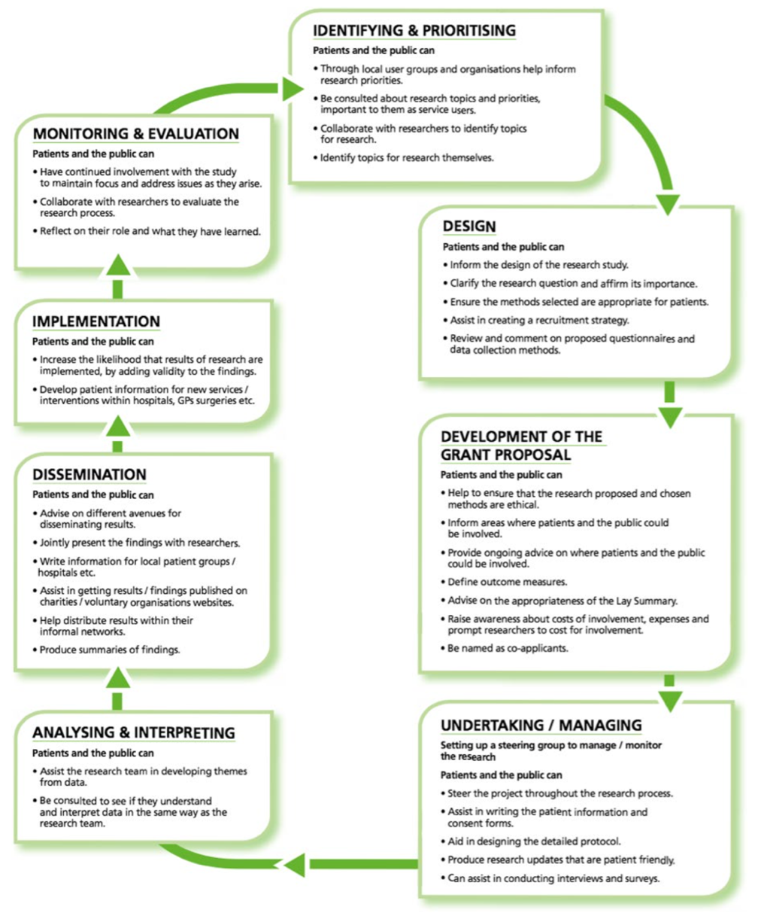
Figure 1: Reproduced from National Institute for Health Research², page 14.

Recording PPI activities

The purpose of this tool is to provide researchers with a comprehensive and usable recording checklist to document patient and public involvement in research. The tool was designed by researchers (Holly Bear, Elizabeth Bradburn, Melanie Fleming, Silvia Messina, Sarah Vollam), to map on to the Guidance for Reporting Involvement of Patients and the Public from Staniszewska et al. (GRIPP2)³ reporting checklist. Using evidence-informed tools to record and report PPI activities should help improve the quality, transparency, and consistency of PPI in research.

The tables below are intended as a guide for aspects which you may wish to record. You may want to add other points/sections, or you may not need to answer all sections. We suggest you try to complete the tool as you conduct the PPI activities, rather than trying to recall the details later.

If you are including PPI at multiple stages in the research cycle, you can copy and paste the methods and results tables as many times as you need. We suggest you then bring all your PPI activities for the research project together to form conclusions and reflections. Case examples are provided alongside this document.

If you are regularly involving the same group of people (e.g. an ongoing advisory group) then you may find it more useful to use our alternative recording tool – “Recording tool for regular, repeated PPI groups”

Aim
- What is the rationale and aim of PPI in the research? (i.e., What is the purpose and what do you hope to achieve from PPI?)
This could be an overarching aim, or multiple specific aims for each PPI activity completed

Methods: Provide a clear description of the methods used for PPI in the study – Copy and paste for each PPI activity
Please consider GDPR, i.e., not naming people unless appropriate.
2.1. At what stage of the research cycle does this recording apply to?
See figure 1 for guidance

Identifying & prioritising | ¨ | Design | ¨ | Grant proposal |  | ¨ | Undertaking/managing | ¨
Analysing and interpreting | ¨ | Dissemination | ¨ | Implementation |  | ¨ | Monitoring & evaluation | ¨
Other:

2.2. Who conducted/was responsible for the PPI activity? (tick all that apply)

Research Assistant | ¨ | Student | ¨ | Postdoc |  | ¨ | Principal Investigator | ¨
Clinician (specify details below) | ¨ | Existing PPI partner/contributor |  | ¨
Other (please specify):
Were they a member of the research team for the project or independent?

Additional information (if needed):

2.3. Who were involved in the activity as PPI contributors?
Person/people with lived experience | ¨ | Person/people with risk of the condition | ¨ | Family member/ friend of person with condition |  | ¨ | Member of the public | ¨
Other (please specify, e.g. charity representative):

How many people were involved? |  |  |  |  | Date, time, location (if applicable):
How were they recruited?

Were they reimbursed for their time? If so, how, how much? If not, why not?

What were their demographic characteristics? You should consider whether PPI contributors are reflective of your target population and/or from diverse backgrounds.

2.4. How did you involve them?
e.g., did you use a survey, focus groups or interviews? And how was this recorded?
Are they a partner in the process (e.g. co-production)?

  - Results: What were results of PPI, including both positive and negative outcomes? – copy and paste for each PPI activity
- What did contributors say or suggest? | - As a result, what feedback did you incorporate or change in the study? | - Why did or didn’t you incorporate their suggestions or feedback?
3.2 What went well?

3.3 What didn’t go well?

3.4 What was the impact that this PPI activity has had on the research?

3.5 What was the impact that this PPI activity had on the individuals involved (Including patients and researchers if known) (if possible, ask your contributors directly, rather than making assumptions about the impact on them)

3.6 Were there any wider impacts?

Discussion and conclusions - use this section to summarise the effects of all your PPI activities combined on the research
4.1 How did the PPI influence the research overall?

4.2 How did you (or how do you intend) to feed back to the PPI representatives about how your research changed as a result of their input?
For guidance on feedback, see https://www.clahrc-eoe.nihr.ac.uk/wp-content/uploads/2016/05/Guidance-for-Researchers-PPI-Feedback_2018.pdf

Reflections - use this section to reflect on your PPI activities. This section is important to improve your own PPI engagement in the future. We also encourage you to share this learning with others so they too can learn from your experience.
5.1 Want went well and what will you take forward to your next PPI activity?

5.2 What didn’t go so well and how would you do things differently next time to mitigate these issues?

5.3 How do you plan to disseminate this learning?

References

1. Health Research Authority (HRA). What is public involvement in research? https://www.hra.nhs.uk/planning-and-improving-research/best-practice/public-involvement/ . Accessed 15th July 2022.

2. National Institute for Health Research. Patient and public involvement in health and social care research: A handbook for researchers. Leeds: NIHR. https://www.rds-yh.nihr.ac.uk/wp-content/uploads/2015/01/RDS_PPI-Handbook_2014-v8-FINAL-11.pdf . Accessed 15th July 2022.

3. Staniszewska S, Brett J, Simera I, Seers K, Mockford C, Goodlad S, Altman DG, Moher D, Barber R, Denegri S, Entwistle A, Littlejohns P, Morris C, Suleman R, Thomas V, Tysall C. GRIPP2 reporting checklists: tools to improve reporting of patient and public involvement in research. BMJ. 2017 Aug 2;358:j3453. doi: 10.1136/bmj.j3453. PMID: 28768629; PMCID: PMC5539518.

