Introduction to Patient and Public Involvement in Research (PPI)

Public and public involvement (PPI) in health and social care research is defined by the Health Research Authority¹ as being “done ‘with’ or ‘by’ the public, not ‘to’, ‘about’ or ‘for’ them.”

This includes, for example, working with research funders to prioritise research, offering advice or expertise as members of a project steering group, commenting on and developing research materials, undertaking interviews with research participants.

There is increasing evidence that health research conducted with meaningful PPI improves research and achieves better outcomes for patients.

There is good information about PPI on the NIHR Oxford Biomedical Research Centre website

https://oxfordbrc.nihr.ac.uk/ppi/ppi-researcher-guidance/

It is important to be able to reflect on your PPI activities to ascertain how patient and public input influenced your study. This may be important for many reasons, including: feeding back to funders; as part of ethics applications; for publication purposes; and to learn and adapt the way that PPI is incorporated into research over time.

PPI can potentially be conducted at any stage of the research cycle. Below is an example demonstrating the framework for PPI in research.
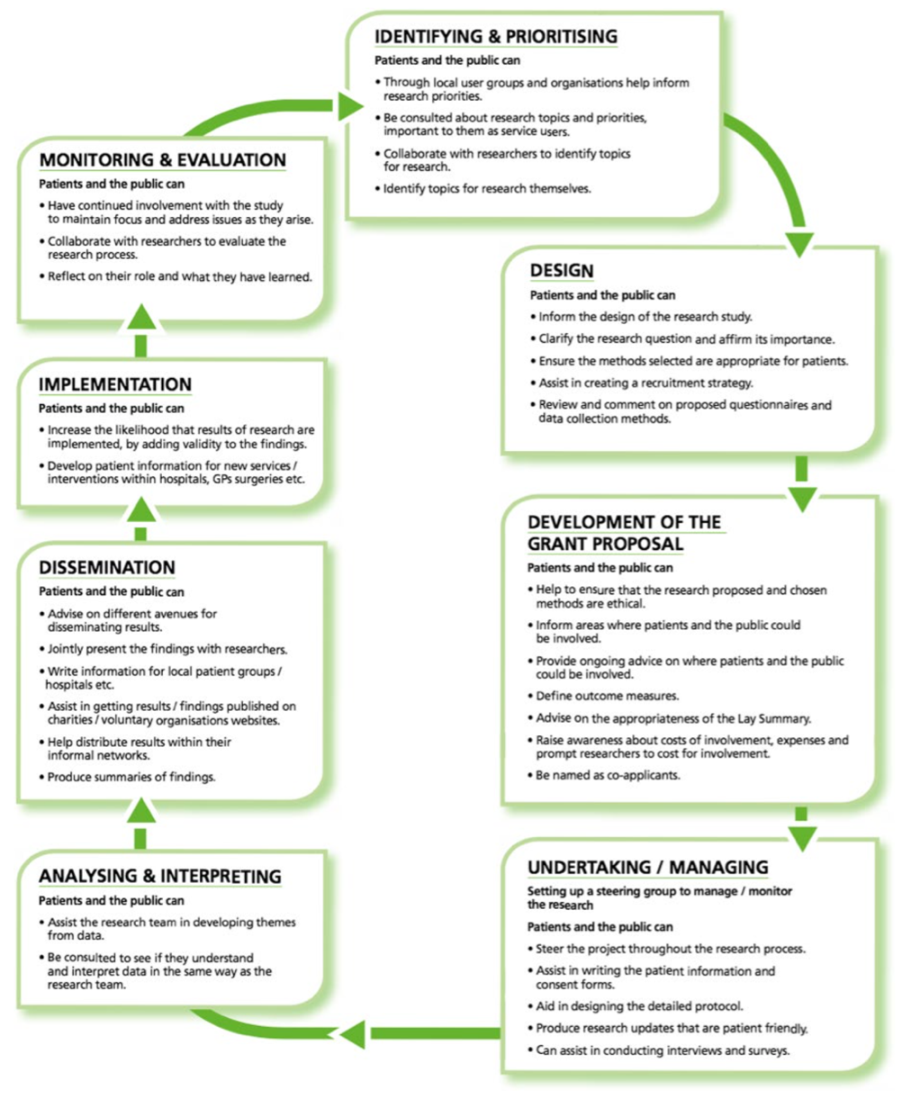
Figure 1: Reproduced from National Institute for Health Research², page 14.

Recording PPI activities

The purpose of this tool is to provide researchers with a comprehensive and usable recording checklist to document patient and public involvement in research. The tool was designed by researchers (Holly Bear, Elizabeth Bradburn, Melanie Fleming, Silvia Messina, Sarah Vollam), to map on to the Guidance for Reporting Involvement of Patients and the Public from Staniszewska et al. (GRIPP2)³ reporting checklist. Using evidence-informed tools to record and report PPI activities should help improve the quality, transparency, and consistency of PPI in research.

The tables below are intended as a guide for aspects which you may wish to record. You may want to add other points/sections, or you may not need to answer all sections. We suggest you try to complete the tool as you conduct the PPI activities, rather than trying to recall the details later.

This tool is intended for regular, repeated activities with the same group of contributors (e.g. an ongoing advisory group). You can copy and paste the methods and results tables as many times as you need (e.g.. for each meeting held).

If you are involving different people across different stages of your research project, or using different methods then you may find it more useful to use our alternative recording tool – “PPI Recording tool 1”

Aim
- What is the rationale and aim of PPI in the research? (i.e. What is the purpose of the group and what do you hope to achieve from PPI?)

Methods: Provide a clear description of the methods used for PPI in the study
Please consider GDPR, i.e., not naming people unless appropriate.
2.1. At what stage of the research cycle does this group apply to?
See figure 1 for guidance, choose all that apply

Identifying & prioritising | ¨ | Design | ¨ | Grant proposal |  | ¨ | Undertaking/managing | ¨
Analysing and interpreting | ¨ | Dissemination | ¨ | Implementation |  | ¨ | Monitoring & evaluation | ¨
Other:

2.2. Who are the PPI contributors involved in the group?
Person/people with lived experience | ¨ | Person/people with risk of the condition | ¨ | Family member/ friend of person with condition |  | ¨ | Member(s) of the public | ¨
Other (please specify, e.g. charity representative):

How many PPI contributors are typically in the group?

How were they recruited?

Are they reimbursed for their time? If so, how, and how much? If not, why not?

What are their demographic characteristics? You should consider whether PPI contributors are reflective of your target population and/or from diverse backgrounds.

Meeting details – copy and paste for each PPI meeting held
3.1 Who conducted / was responsible for running the meeting?
Research Assistant | ¨ | Student | ¨ | Postdoc | ¨ | Principal Investigator ¨
Clinician (specify details below) | ¨ | Existing PPI partner/contributor |  | ¨
Other (please specify):
Were they a member of the research team for the project or independent?

Additional information (if needed):

3.2 Meeting date / time:

3.3 Meeting format:
In person ¨ |  | Online ¨ |  | Hybrid ¨
Other (please specify):
3.4 How many people attended (you may wish to note how many PPI contributors and how many researchers separately):

3.5 What was the aim of the meeting? (if different or more specific than that provided in the first section)

Additional information (if needed):

3.6 What were the outcomes, including both positive and negative outcomes?
Copy and paste for each meeting, adding additional rows as needed
- What did contributors say or suggest? | - As a result, what feedback did you incorporate? | - Why did or didn’t you incorporate their suggestions or feedback?
3.7 What went well?

3.8 What didn’t go well?

Discussion and conclusions - use this section to summarise the effects of all your PPI activities combined on the research
4.1 How did the PPI influence the research overall?

4.2 What was the impact that this PPI activity had on the individuals involved (Including patients and researchers if known) (if possible, ask your contributors directly, rather than making assumptions about the impact on them)

4.3 Were there any wider impacts?

4.4 How did you (or how do you intend) to feed back to the PPI representatives about how your research changed as a result of their input?
For guidance on feedback, see https://www.clahrc-eoe.nihr.ac.uk/wp-content/uploads/2016/05/Guidance-for-Researchers-PPI-Feedback_2018.pdf

Reflections - use this section to reflect on your PPI activities. You may wish to do this after each meeting, or to look back over a longer period (e.g. once a year). This section is important to improve your own PPI engagement in the future. We also encourage you to share this learning with others so they too can learn from your experience.
5.1 Want went well and what will you take forward to your next PPI activity?

5.2 What didn’t go so well and how would you do things differently next time to mitigate these issues?

5.3 How do you plan to disseminate this learning?

References

1. Health Research Authority (HRA). What is public involvement in research? https://www.hra.nhs.uk/planning-and-improving-research/best-practice/public-involvement/ . Accessed 15th July 2022.

2. National Institute for Health Research. Patient and public involvement in health and social care research: A handbook for researchers. Leeds: NIHR. https://www.rds-yh.nihr.ac.uk/wp-content/uploads/2015/01/RDS_PPI-Handbook_2014-v8-FINAL-11.pdf . Accessed 15th July 2022.

3. Staniszewska S, Brett J, Simera I, Seers K, Mockford C, Goodlad S, Altman DG, Moher D, Barber R, Denegri S, Entwistle A, Littlejohns P, Morris C, Suleman R, Thomas V, Tysall C. GRIPP2 reporting checklists: tools to improve reporting of patient and public involvement in research. BMJ. 2017 Aug 2;358:j3453. doi: 10.1136/bmj.j3453. PMID: 28768629; PMCID: PMC5539518.

