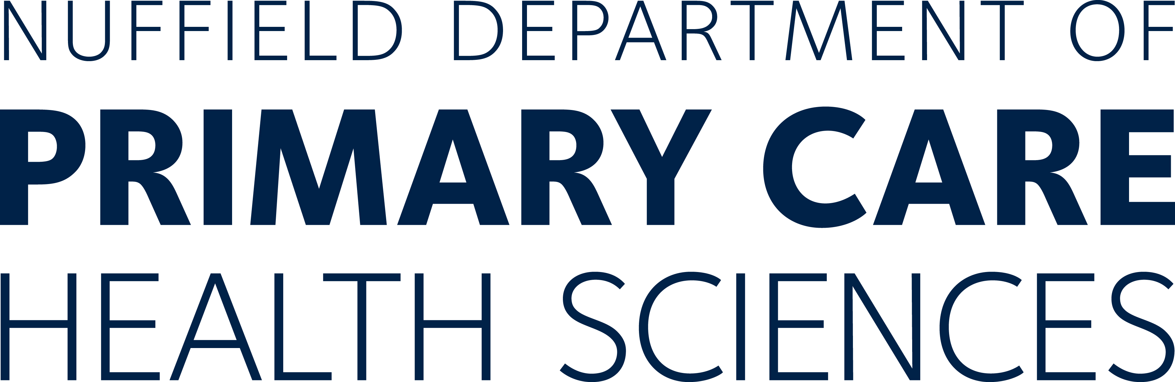



**PARTICIPANT INFORMATION SHEET**

OXFORD UNIVERSITY STUDY: “FACE MASKS and EXERCISE”

Thank you for your interest in taking part in our research study. Before you decide, it is important that you understand why the research is being done and what it would involve for you. Please take time to read this information, and discuss it with others if you wish. *If there is anything that is not clear, or if* you *would like more information, please ask contact the study team using the details below.*

# What is the purpose of the study?

# We are a group of research scientists at the University of Oxford seeking to determine the impact of wearing face masks during aerobic exercise, for example during a run, bike ride or row. This study is of vital importance to inform policymakers as they make decisions related to the easing of lockdown measures in England during the COVID-19 pandemic. The UK government outlined measures to enable indoor gyms and sports facilities to re-open on 25 July 2020. The current guidance states that “all forms of face coverings may restrict breathing efficiency and should not be used during exercise except on specific advice from a physician”. This is in contrast to the wider public health advice to wear face masks in public indoor settings with the aim of reducing transmission of the COVID-19 virus. We seek to measure the impact face masks have in the oxygen levels of fit and healthy young adults during exercise.

**What is the purpose of the pilot study?**

The purpose of this study is to determine whether wearing face masks during exercise causes healthy volunteers leads to a lower level of oxygen in the bloodstream, alters peoples heart rates, or causes other symptoms such as breathlessness or headaches. We also want to know whether people find wearing a face mask impacts on comfort and ease of exercise when compared to exercise without a face covering.

**Why have I been invited?**

We are seeking fit and healthy 18-35 year old volunteers willing to partake in this trial. You must currently be living in the United Kingdom to be eligible to take part.

**Do I have to take part?**

No, taking part is entirely voluntary and you can withdraw at any time if you later change your mind, without giving a reason.

# What will happen to me if I decide to take part?

If you would like to take part you will need to submit an expression of interest via our website and provide your consent to take part. At this stage we will ask some basic information about you to check that you are eligible to be in the study and also to allow us to get in contact directly. If you are selected to take part, we will send you a study information pack, containing the finger probe that will measure your oxygen levels and details of what to do on the day.

The study session can take place at a time and location of your own choosing. For example, it could be at a local park or within the local university gym, dependent on your preferred form of exercise and taking into account any rules on indoor exercise that might be in place at the time. You will be asked not to complete the study visit if you are unwell with a fever, cough, notice a change in your sense of smell or have other symptom of an acute illness.

During the study visit you will be asked to exercise, either by running, cycling or rowing, up to when the exercise feels strenuous – typically a heart rate of approximately 200 beats per minute minus your age (e.g. a 25 year-old will exercise such that their heart rate sustains at 175bpm). You will undertake the exercise four times for 15 minutes each time – wearing 3 different masks and once without a mask. The masks will be one tight fitting mask, one soft surgical mask, and one cloth mask. The study pack we send you will tell you which order to wear the masks in.

In between you will be given 5 minutes to recover without wearing a mask or exercising. If you feel unable to continue at any point during the exercise you are free to stop and remove the face mask. At that point, you could either decide to end the study or you could opt to try again with one of the other face masks or no mask, depending on what you have left to do.

We will ask you to measure your pulse rate and peripheral oxygen saturation levels at rest and again at the mid-point, end and 1 minute after completion of each 15 minutes of exercise using a monitor, which you wear on your finger. This is easy to take on and off and harmless. You will be asked to record how far you travel and your average speeding using a freely available smartphone app. We anticipate you will be able to complete the exercise and in under 90 minutes in a single session. You will be asked to input all of the information you have recorded into an online survey, which will also ask you questions about how difficult and comfortable you found exercising with each mask on. No further involvement is required beyond this.

# What should I consider?

The main thing to consider is whether you are willing to try exercising whilst wearing a face mask and to record your oxygen levels and heart rate using a finger-tip device. Some people are fine about this while other people may feel uncomfortable at the thought of exercising whilst wearing a mask.

# Are there any possible disadvantages or risks from taking part?

It is possible that you will feel claustrophobic wearing the mask or more short of breath than you would usually whilst exercising. When the study team tried this they did not find this to be the case, but this does not mean you will not. If you feel unwell at any point you are free to stop. We do not anticipate there being a serious risk to your health in exercising in this way.

You will be required to commit around 90 minutes of your time to complete the exercise and we are not able to reimburse people financially for taking part. You will be asked to provide some basic information about your general health and wellbeing. This will be seen by the research team but all of your personal information will be kept anonymous.

# What are the possible benefits of taking part?

The main benefit of taking part is this is an opportunity for you to contribute to improving our understanding of how face masks impact people during exercise. Findings from the study could be used to inform changes to government policy and guidance in the wake of the COVID-19 pandemic.

# Will my General Practitioner/family doctor (GP) be informed of my participation?

No, this is a stand alone, voluntary study and we will not be liaising with your GP about your participation in the study.

# Will my taking part in the study be kept confidential?

Yes. All data reported from the study will be made anonymous. Study information will be kept on a secure, non-networked computer at the University of Oxford. In those stored data, you will be referred to only by a code name (‘pseudonym’). We will keep a separate paper record in an encrypted file of participants’ real names and corresponding code names.

Responsible members of the University of Oxford and the relevant NHS Trust(s) may be given access to data for monitoring and/or audit of the study to ensure that the research is complying with applicable regulations.

# Will I be reimbursed for taking part?

No, we are not able to reimburse people for taking part in this study. We hope that you will be able to complete the single study visit close to home and without you incurring any significant travel or expenses. We are extremely grateful to all people who volunteer their time to help with the study.

# What will happen to my data?

We will keep the research data for up to one year after the end of the data collection, to allow us to analyse it all and write papers and reports. Once these are completed, all data will be destroyed. Anonymised study records may be kept for up to 15 years.

# [What will happen if I don't want to carry on with the study?](http://hra-decisiontools.org.uk/consent/content-sheet-support.html#two)

You can stop at any time. Participation is voluntary and even if you originally said yes, you may change your mind at a later stage. If you withdraw from the study, unless you state otherwise, any information relating to you and the exercise completed that has been collected will be used for research as detailed in this participant information sheet. You are free to request that your data are destroyed at any time during or after the study. Withdrawal will not affect the care you receive from the NHS now or in the future.

# What will happen at the end of the study?

Our research team will analyse the data and write some papers and reports, including a ‘lay summary’. We will provide you with a summary of the findings if you would like us to. You will not be identified from any report or publication placed in the public domain.

# What if you find something unexpected?

If anything happens during the exercise that has a bearing on your future clinical care (for example if you disclose to us that you have a new symptom), we will discuss this with you but suggest you inform your GP as appropriate.

# What if there is a problem?

The University of Oxford, as Sponsor, has appropriate insurance in place in the unlikely event that you suffer any harm as a direct consequence of your participation in this study. NHS indemnity operates in respect of the clinical treatment which is provided.

If you wish to complain about any aspect of the way in which you have been approached or treated during the course of this study, you should contact Professor Trisha Greenhalgh whose details are given below, or Professor Richard Hobbs (Professor Greenhalgh’s line manager, same address). Alternatively, you may contact the University of Oxford Clinical Trials and Research Governance (CTRG) office on 01865 572224, or the head of CTRG, email [ctrg@admin.ox.ac.uk](mailto:ctrg@admin.ox.ac.uk).

# Who is organising and funding the study?

The study team is led by Professor Trisha Greenhalgh, a GP who works at the University of Oxford; she is also custodian of the study information. Professor Greenhalgh’s research is supported by Oxford NIHR Biomedical Research Centre (grant no BRC-1215-20008).

# Who has reviewed the study?

This study has been reviewed and given favourable opinion by Oxford C Research Ethics Committee.

# Further information and contact details:

[Please](mailto:Please) contact the following individual if you would like further information.

Professor Trisha Greenhalgh (Chief Investigator)

Nuffield Department of Primary Care Health Sciences

University of Oxford

Radclilffe Primary Care Building

Woodstock Rd

Oxford OX2 6GG

01865 617835

[trish.greenhalgh@phc.ox.ac.uk](mailto:linnemore.jantjes@phc.ox.ac.uk)

*Thank you for considering taking part.*