***How to use our evidence and gap map?***

This EGM shows recent available evidence exploring the links between e-cigarettes use (“vaping”) and subsequent cigarette smoking in adolescents and young people (under the age of 29 years old) and displays areas where no studies were identified.

On this webpage we provide instructions on how to use our EGM.

Please note that visualizing the EGM works best in a computer rather than in a cell phone screen.

**Evidence and gap map view**

When you open the map, you will see the panel with *options* at the left-hand top side of the browser. This will allow you to personalize how you view the information on the map, as explained on Figure 1.

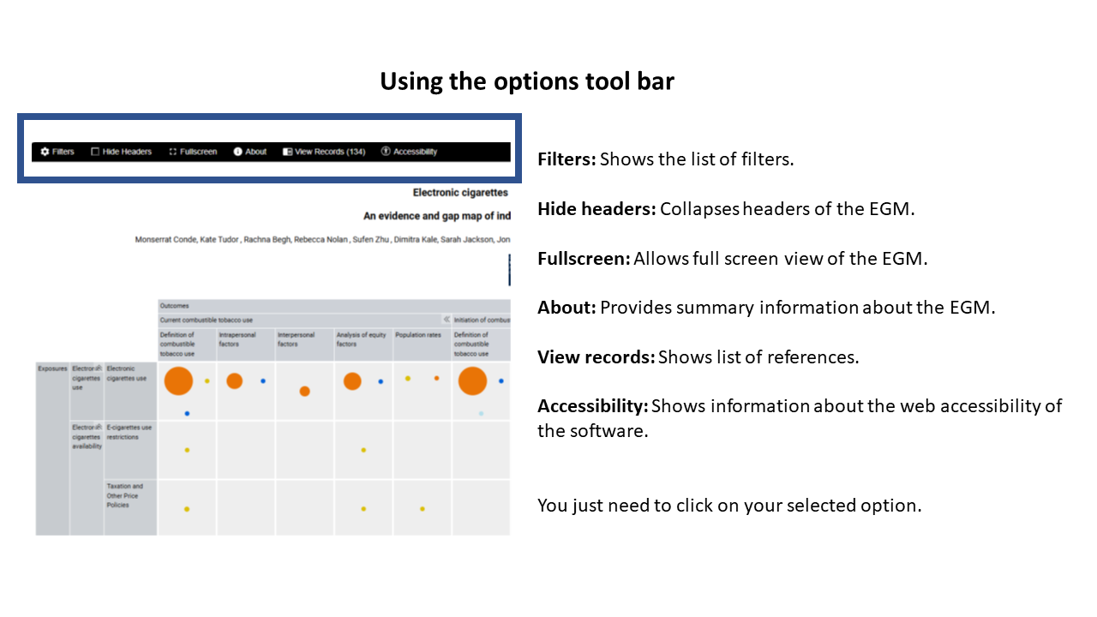

Figure 1: Options tool bar

The rows in the map are exposures categories, while the columns are outcome categories. Header rows (OUTCOMES) and columns (EXPOSURES) can be scrolled through to view all categories. You can expand or minimise categories for each column and row (to view sub-categories) by using the arrows << >>. Please note that this will not work if you have selected to hide the headers on the options tool bar.

**Matrix and cells**

You will see that some cells of the map have “bubbles”, whereas others are empty. Empty cells mean that no studies were found that explore that intersection between exposures and outcomes.

The size of each bubble is proportional to the number of studies that were identified corresponding to that exposure and outcome. Each colour represents a different type of study (individual level studies, population level studies, higher quality systematic reviews and lower quality systematic reviews). The confidence in the research quality of systematic reviews was assessed using a tool called AMSTAR-2. Individual and population level studies were not assessed for the purpose of this EGM. The legend at the bottom left-hand side of the map explains the colour coding of the bubbles.

Clicking on a cell provides the list of studies corresponding to that exposure and outcomes. If you click on a study reference, you will see a summary, publication details and the link to access the study report.

Figure 2 shows an overview of the map.

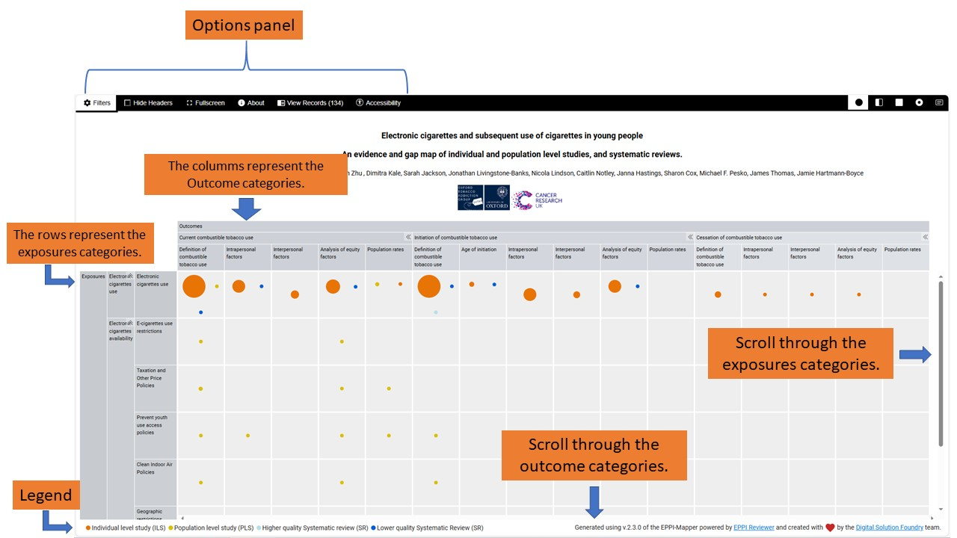

*Figure 2: Overview of the EGM*

**Filters**

This EGM includes filters which allow the map to show evidence just for the selected filter(s) (E.g., only show studies concerning adolescents). You can use this option by clicking on “Filters” on the top-left of the EGM, select the categories and then click on “update.

You can also personalize the visualization style of the map by selecting one of the four options on the “**Style”** menu**:** bubble, heat, donut and mosaic. “Bubble” is the default style.

 Figure 3 shows these steps.

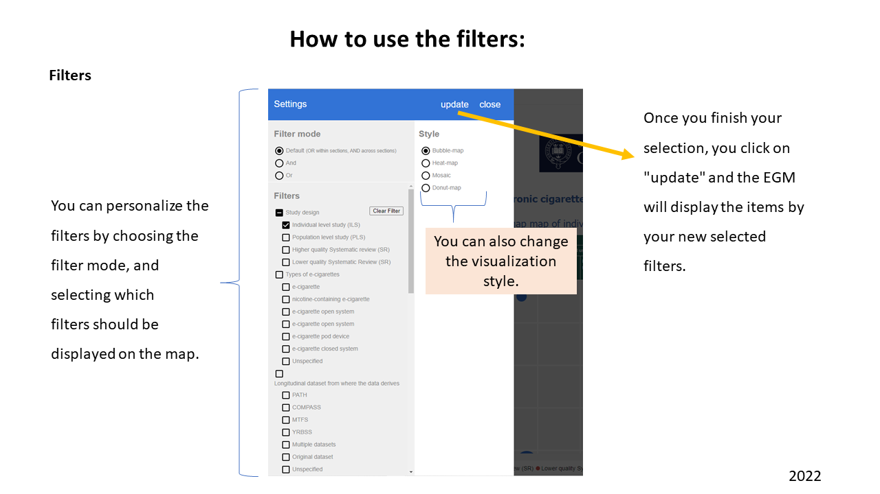

Figure 3: Filters

On the glossary you will find what each of the terms in our EGM mean.