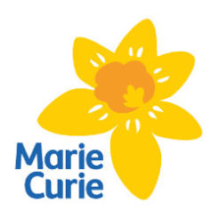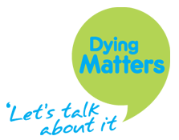

**For further emotional support, speak to your GP or try Talking Space:  
Website:** talkingspaceoxfordshire.org.uk

**Macmillan**  
An organisation that provides physical, emotional and financial support for people affected by cancer. Whatever questions you may have, they exist to support you and your loved ones at every stage of the journey.

**Website:** [www.macmillan.org.uk](http://www.macmillan.org.uk)  
**Macmillan support line:** 0800 808 0000   
*Call them free any day from 8am-8pm.*

**Marie Curie**A resource for those affected by cancer that seeks to provide information and support for you and your loved one. They're there to answer your questions about things like:

* Managing day-to-day care
* Understanding symptoms
* Financial advice

**Website:** [www.mariecurie.org.uk](http://www.mariecurie.org.uk)  
**Marie Curie support line:** 0800 090 2309  
*Call them free Mon-Fri 8am-6pm or Sat 11am-5pm*

**Carers Trust**A charity for unpaid carers that aims to support by providing:

* Information.
* Replacement care.
* Grants.
* Emotional support.

**Website:** www.carers.org   
*There is also an online forum where you can chat to other carers.*

**Dying Matters**Provides a good starting point for information relating to the end of life. They have a variety of online leaflets covering a range of topics, e.g. practical and financial issues at the end of life.

**Website:** dyingmatters.org

**Cruse Bereavement Care**A charity which seeks to provide somewhere to turn when someone dies. It is a space where you can find advice and read stories of others who have experienced bereavement.

**Website:** [www.cruse.org.uk](http://www.cruse.org.uk)  
**Cruse helpline:** 0808 808 1677  
*Call them free Mon-Fri 9:30am-5pm.*

**Age UK**Provides advice on caring for someone with dementia. They also explain other conditions of old age, e.g. hearing loss, incontinence, and give advice on how to give support for these issues.

**Website:** [www.ageuk.org.uk](http://www.ageuk.org.uk)  
**Age UK advice line:** 0800 678 1602   
*Call them free any day 8am-7pm.*



Caring for a loved one with a terminal illness can be overwhelming at times.

We are also here to support you and your loved one during this time.

**Contact us here: 01235 770 245**

Here you can find some organisations that want to help you by providing information, practical advice and emotional support.

**Sue Ryder South Oxfordshire Palliative Care Hub**An alternative to Sobell House for hospice care. Provides both in-patient palliative care at Nettlebed Hospice and hospice-at-home palliative care.

**Website:** [www.sueryder.org](http://www.sobellhouse.org)  
**Telephone:** 0330 053 6092. *Call any day from 8am-6pm.*  
**Address:** Joyce Grove, Nettlebed, Henley-on-Thames, RG9 5DF

**Sobell House**A hospice which provides palliative care to residents of Oxfordshire. Their website has lots of information about the services they offer, which includes support for carers, and emotional & spiritual support.

**Website:** [www.sobellhouse.org](http://www.sobellhouse.org)  
**Telephone for general enquiries:** 01865 225860   
**Address:** Sobell House, Churchill Hospital, Headington, OX3 7LE